

##### COUNTERFEIT CURRENCY DETECTION

##### MINOR PROJECT – III

**Submitted in Partial Fulfillment of the Requirements for the Award of the**

**Degree of**

#### MASTER OF COMPUTER APPLICATIONS(M.C.A.)

**Lakshay Rustagi (04111604422)**

**Sanchit Talreja (35211604422)**

**Jyoti Sharma (36011604422)**

##### MCA – 3rd SEMESTER



**BHARATI VIDYAPEETH’S INSTITUTE OF COMPUTER APPLICATIONS AND MANAGEMENT (BVICAM)**

**(GURU GOBIND SINGH INDRAPRASTHA UNIVERSITY) NEW DELHI**

### CANDIDATE’S DECLARATION

I at this moment declare that the work which is being presented in this project work entitled “**COUNTER FEIT CURRENCY DETECTION**” in partial fulfilment of the requirements for the award of the degree of **Master in Computer Applications at Bharati**

**Vidyapeeth’s Institute of Computer Applications and Management (BVICAM), New Delhi** is an authentic record of my work carried out during the period August 2023 to November 2023 under the supervision and guidance of Dr. Saumya Bansal **(Assistant Professor, BVICAM)**.

I have not submitted the matter embodied in this project work anywhere for any degree or diploma award.

**Lakshay Rustagi (04111604422)**

**Jyoti Sharma (36011604422)**

**Sanchit Talreja (35211604422)**

### ACKNOWLEDGEMENT

It is my proud privilege to express my profound gratitude to the entire management of Bharati Vidyapeeth’s Institute of Computer Applications and Management and the teachers of the institute for providing me with the opportunity to avail myself of the excellent facilities and infrastructure. The knowledge and values taught have proved to be of immense help at the very start of my career. Special thanks to Hon’ble Founder, Bharati Vidyapeeth, Pune for having provided us with an excellent infrastructure at BVICAM.

I am grateful to Dr Saumya Bansal (Project Guide, BVICAM, New Delhi) for her astute guidance, constant encouragement and sincere support for this project work.

I feel proud and privileged to express my deep sense of gratitude to all those who have helped me in presenting this assignment. I would be failing in my endeavour if I did not place my acknowledgement.

**Lakshay Rustagi (04111604422)**

**Jyoti Sharma (36011604422)**

**Sanchit Talreja (35211604422)**

**TABLE OF CONTENTS**

**CHAPTER 1: INTRODUCTION**

* 1. Problem Description
  2. Brief Introduction

1.3 Proposed Solution

**CHAPTER 2: PROJECT DESCRIPTION**

* 1. System Specification hardware and software requirements
  2. Methodology Used
  3. Model used

**CHAPTER 3: FUNCTIONALITIES**

* 1. Screenshots of Running Project
  2. Implementation and Results
  3. Advantages and Disadvantages of the System

**CHAPTER 4: CONCLUSION AND FUTURE SCOPE**

**CHAPTER 5: BIBLIOGRAPHY**

**INTRODUCTION**

* 1. **PROBLEM DESCRIPTION**

The circulation of counterfeit currency poses a significant threat to financial systems and can lead to economic instability. Indeed there has been an increasing number of counterfeit notes in the market. Achieving a high level of accuracy and reliability in fake currency detection is crucial for financial institutions, businesses, and authorities to safeguard against economic fraud and ensure the stability of financial systems. The work aims to accurately classify and differentiate between authentic and fake currency notes by analysing various features such as texture, colour, patterns, and other relevant characteristics. The success is measured by the model's ability to accurately identify counterfeit currency while minimizing false detections of genuine notes. to solve this problem, a dedicated dataset of genuine and counterfeit notes of Indian currency is used, and features are extracted using the Conv2d, and MaxPooling2d layers of the CNN model from the currency note's images, these features include depth, spatial dimension etc. CNN (Convolutional Neural Network) is used as the deep learning model for fake currency detection and trained the selected model on the dataset, using the relevant features as input and accuracy matrix for the final output. The dataset is divided into training and testing parts based on tenfold cross-validation wherein the training dataset is used to build the predictor. The testing dataset was used for evaluation purposes, achieving an accuracy of …%.

* 1. **Brief Introduction**

In an increasingly digitized world, where cashless transactions are promoted and are widely popular, one may easily assume that the threat of fake currency has long passed. However, fake currency continues to be one of the most critical issues in the modern interconnected world, affecting the integrity of financial systems, the stability of the economy, and the daily lives of ordinary individuals. During the 2021-22 period, the rate of Fake Indian Currency Notes (FICN) detected at the RBI was 6.9% and the rate of FICN detected at other banks was 93.1%. Fake banknotes have been flooding the markets forever and the emergence of newer technologies has opened new ways for counterfeiters to exploit the opportunities in their favor resulting in imperil the struggles of building and maintaining a secure and foolproof [economy](https://www.financialexpress.com/policy/economy/). As per the National Crime Record Bureau’s reports spanning from 2016 to 2021, fake currency amounting to a total face value of Rs 199.54 crore over five years has been seized by law enforcement authorities. The biggest victims are the consumers who are unaware of the traps and blindly accept fake currency. A person who has fallen victim to the counterfeit trade will lose faith in the monetary system. If people become unsure about the authenticity of the money they receive, they may become resistant to engaging in cash transactions, leading to a slowdown in economic activities. Figure 1 shows

Statistics of Detected Counterfeit Banknotes of rupee 500 from year 2017-2022.

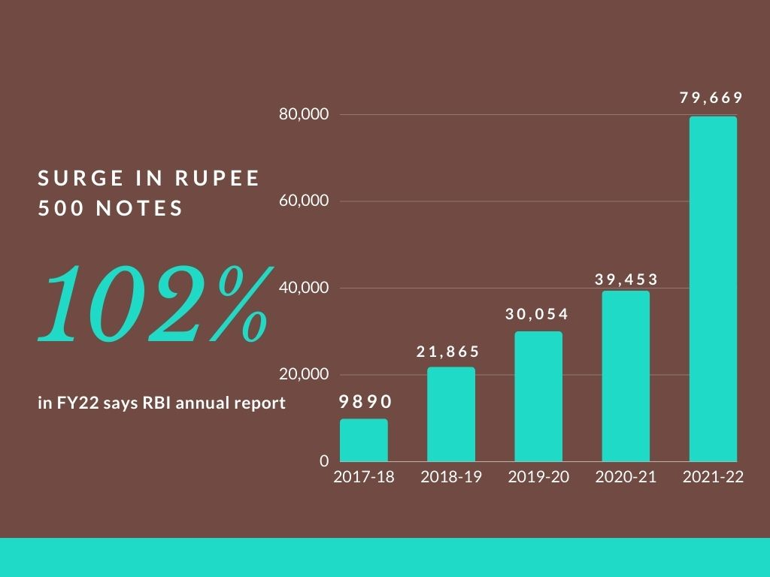

**Fig.1: Statistics of Detected Counterfeit Banknotes**

The manual testing of all notes in transactions is a very time-consuming process. Thus, automatic methods for banknote recognition as fake or genuine are required in many areas selling goods online or in vending machines. Every year Reserve Bank of India face fake currency notes or destroyed notes therefore handling of large volume of counterfeit notes can create additional problems thus, by involving artificial intelligence and machine learning one can make the note recognition process simpler and efficient.

In this work, we have proposed a fake currency note detection technique using CNN architecture.

1. Convolutional Layers: - The first Conv2D layer has 32 filters with a 3x3 kernel, using the ReLU activation function. The input shape is set to (128, 64, 3), indicating an image with dimensions 128x64 pixels and 3 colour channels.

- MaxPooling2D layer with a pool size of (2, 2) follows to downsample the spatial dimensions.

- The second Conv2D layer has 64 filters with a 3x1 kernel and uses the ReLU activation function. Another MaxPooling2D layer follows.

- The third Conv2D layer has 128 filters with a 3x3 kernel, again using the ReLU activation function, followed by another MaxPooling2D layer.

2. Flatten Layer: - This layer is added to flatten the output from the convolutional layers into a 1D array, preparing it for the fully connected (dense) layers.

3. Dense Layers: - The first Dense layer has 256 units with the ReLU activation function.

- The final Dense layer has 1 unit with a sigmoid activation function, which is typical for binary classification problems. It outputs a probability indicating the likelihood of the input belonging to the positive class.

### This model architecture is suitable for image classification tasks, especially binary classification problems like fake currency detection. We have used (name of the dataset) dataset for training and validating the proposed method encompassing both genuine and counterfeit currency notes, thereby ensuring a comprehensive and representative learning environment. The model's functionality is enhanced by the integration of edge detection, a foundational technique in image processing renowned for its effectiveness in detecting and extracting features. This process plays a pivotal role in the model's ability to identify points within digital images where abrupt changes in brightness occur, contributing significantly to its discernment capabilities. In addition, the project incorporates the essential technique of image segmentation, which involves subdividing images into distinct sub-regions. The extent of this division depends on the inherent complexities of the problem being addressed. Specifically, for monochromatic images, the segmentation algorithm analyzes image properties such as discontinuity and similarity. This analytical approach enhances the model's ability to delineate relevant regions within the images. It is noteworthy that the primary objective of this endeavour is the thorough scrutiny of Indian currency notes, and the combination of edge detection and image segmentation strengthens the model's capacity to comprehend and interpret the intricate details present in these currency images. Upon analysis, if a note is determined to be genuine, if the accuracy>50% is presented on the screen, signalling the model's discernment of inauthentic currency.

### 1.3 PROPOSED SOLUTION

The manual identification of fake notes is a very time-consuming task in banking or selling goods. Therefore, the Counterfeit note detection system detects counterfeit banknotes in India based on particular features with the help of which the system can decide whether the Banknote is genuine or not. The proposed approach is discussed in a step-wise fashion below:

**Fig.2 and Fig.3 of genuine and counterfeit note images**

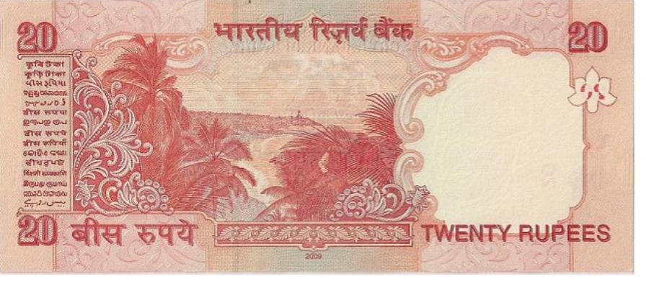

**Fig.2: Rs.20 banknote image**

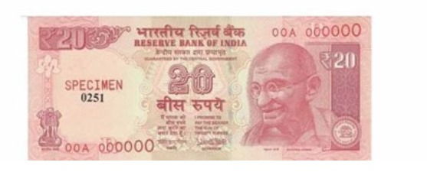

**Fig.2: Rs.20 counterfeit note image**

Methodology for Fake Currency Detection Using CNN Model

1. Data Pre-processing is done by gathering a dedicated dataset that contains images of both genuine and fake currency notes then we Organized the dataset into subdirectories for each class i.e. 'fake' and 'genuine'.We have used (dataset name) dataset for creating and validating notes as genuine or fake. At first, data preprocessing is done using the image data generator for data augmentation. Secondly, the images are resized to a consistent size because Neural networks, especially convolutional neural networks (CNNs), typically expect input data of consistent dimensions. Resizing ensures that all images fed into the model have the same height and width, allowing for the creation of consistent input tensors. Then, normalization is done because Normalizing pixel values to a specific range (e.g., [0, 1] or [-1, 1]) improves numerical stability during training. Neural networks tend to perform better when input values are within a certain range, and normalizing helps achieve this. At last, we divided the dataset into training and validation sets using the flow_from_directory function.

**Fig.3 and Fig.4 of original and resized note images**

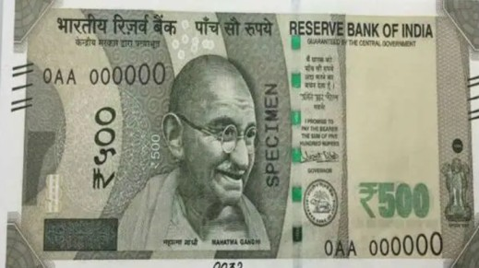

**Fig.3: Rs.500 banknote image**

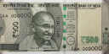

**Fig.4: Rs.500 resized banknote image (128x64 pixels)**

1. Model Architecture is made using a Convolutional Neural Network (CNN) it is a network architecture for deep learning that learns directly from data. CNNs are particularly useful for finding patterns in images to recognize objects, classes, and categories. They can also be quite effective for classifying audio, time series, and signal data. We have designed the CNN model with three convolutional layers i.e. ConV2d layer, dense layer followed by max-pooling layers. We have added a dense layer for feature extraction and a final sigmoid-activated dense layer for binary classification. Then we Compiled the model using the Adam optimizer as Adam is an adaptive learning rate optimization algorithm. It adjusts the learning rates of individual parameters based on past gradients. This adaptability can lead to faster convergence and improved performance, especially when dealing with different scales of gradients - Adam is relatively easy to use, and its default hyperparameters often work well for a variety of tasks. This makes it suitable for quick experimentation and prototyping. and binary cross-entropy loss. Accuracy matric is used for the final evaluation.
2. ImageDataGenerator- Data Generator is set up for training and validation using flow_from_directory, specified batch size, target size, and class mode ('binary'). For Model Training we have trained the CNN model using the fit method on the training generator at last we validated the model using the validation generator.
3. For model evaluation we have created Test Data Generator using flow_from_directory for the evaluation set. For consistent evaluation, we ensured 'shuffle' is set to False. Used evaluation method to compute the test loss and accuracy. Then printed the training and test accuracy for performance analysis.
4. For Predictions and Threshold Adjustment we Generated predictions on the test set using the trained model. Then predicted probabilities to class labels based on a threshold (e.g., 0.5).
5. For Performance Analysis the confusion matrix is computed using the confusion matrix from sci-kit-learn. Then Visualized the confusion matrix using Seaborn. Lastly, we Printed a classification report with precision, recall, and F1-score.

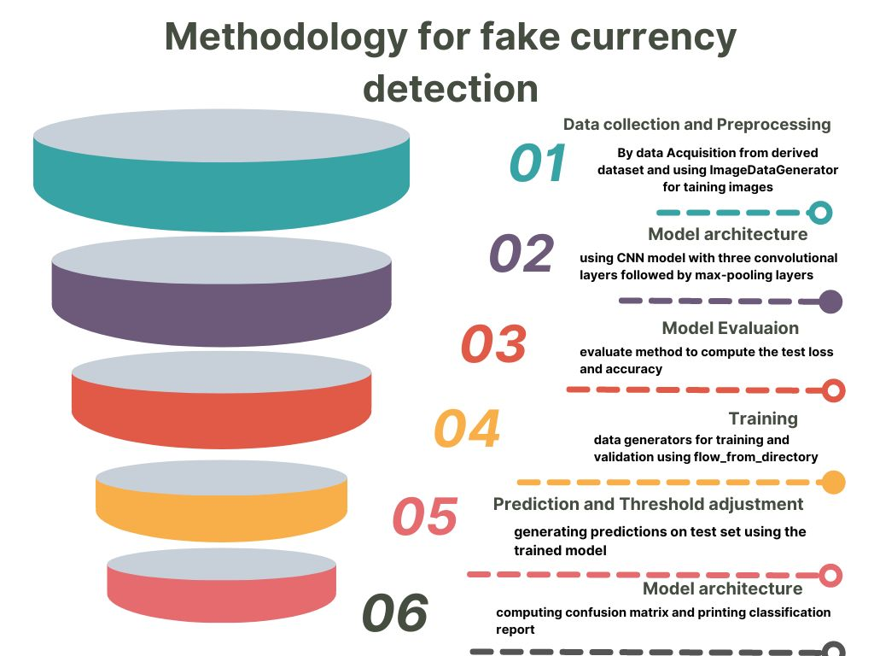

# PROJECT DESCRIPTION

### SYSTEM SPECIFICATION SOFTWARE AND HARDWARE

* **REQUIREMENTS:**

1. **SOFTWARE REQUIREMENTS: -**

Integrated Development Environment (IDE):

Jupiter Notebook

1. **HARDWARE REQUIREMENTS: -**

Working With:

ram: 4 GB and above

storage: 40 GB and above

### METHODOLOGY USED

* **AGILE METHODOLOGY**:

The Agile methodology is a project management approach that involves breaking the project into phases and emphasizes continuous collaboration and improvement. Teams follow a cycle of planning, executing, and evaluating.

### 2.3 MODEL USED

##### CNN MODEL: -

This model consists of the following components:

**Convolutional layers:** Three sets of Conv2D and MaxPooling2D layers to capture hierarchical features in the input images.

**Flatten layer:** Flattens the output from the convolutional layers to a 1D array.

**Dense layers:** Two fully connected (dense) layers for further feature processing.

**Output layer:** A dense layer with a sigmoid activation function, suitable for binary classification.

If you have more than two classes, you should use 'softmax' activation and 'categorical_crossentropy' loss.

The model is then compiled using the Adam optimizer, binary Cross entropy loss (suitable for binary classification), and accuracy as the evaluation metric.

In a Convolutional Neural Network (CNN) like the one described in the code you provided, the features that the machine is learning and extracting are hierarchical representations of patterns in the input images.

**Model Elaboration:** -

**Convolutional Layers:** These layers use convolutional operations to apply filters (kernels) to the input image. These filters act as feature detectors and learn to recognize simple patterns like edges, textures, and basic shapes.

**MaxPooling Layers:** After convolution, pooling layers down-sample the spatial dimensions. MaxPooling, in particular, retains the most important information from the convolutional layers, reducing spatial dimensions while preserving essential features.

**Flatten Layer:** After several convolutional and pooling layers, the Flatten layer is used to convert the multi-dimensional output into a one-dimensional array. This prepares the data for the fully connected layers.

**Dense Layers:** These fully connected layers process the flattened features. The neurons in these layers learn to combine the lower-level features (learned by convolutional layers) into higher-level representations. The number of neurons in the last dense layer corresponds to the number of classes in the classification task.

**Output Layer:** The final layer, using a sigmoid activation function in your case, produces a binary output. It indicates the likelihood of the input belonging to a particular class.

The learning process involves adjusting the weights of the network during training using backpropagation and optimization algorithms. The convolutional layers learn to extract hierarchical and spatial features from the input images, and the dense layers learn to combine these features for the final classification.

In essence, the model learns to recognize and extract features relevant to the classification task through the training process. The specifics of the learned features can be complex and may not be easily interpretable by humans, but they capture the relevant patterns for the given tasks

**FUNCTIONALITIES**

**3.1 SCREENSHOTS OF RUNNING PROJECT**

**Screenshot 1-**

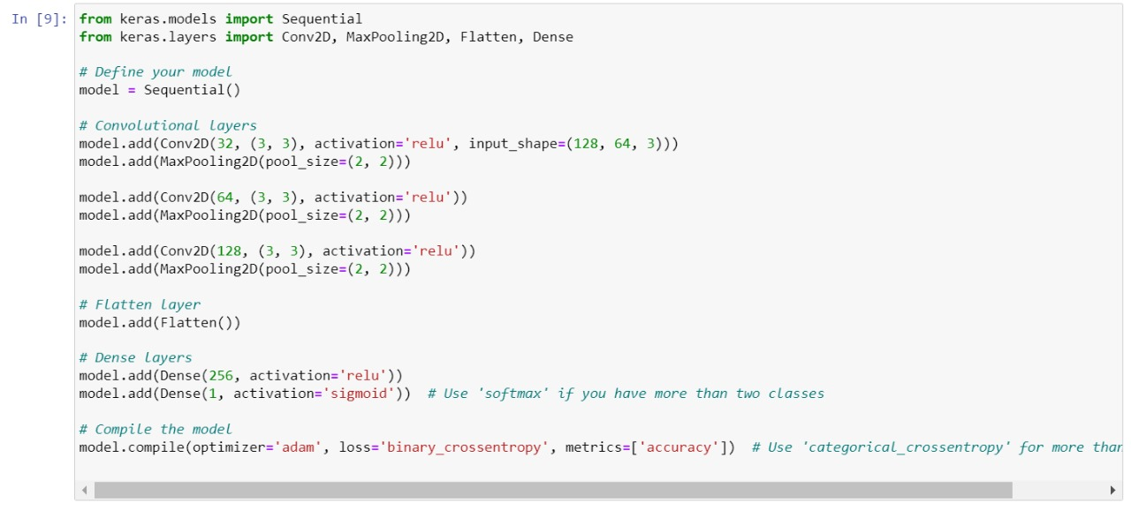

### Screenshot 2-

### Screenshot 3-

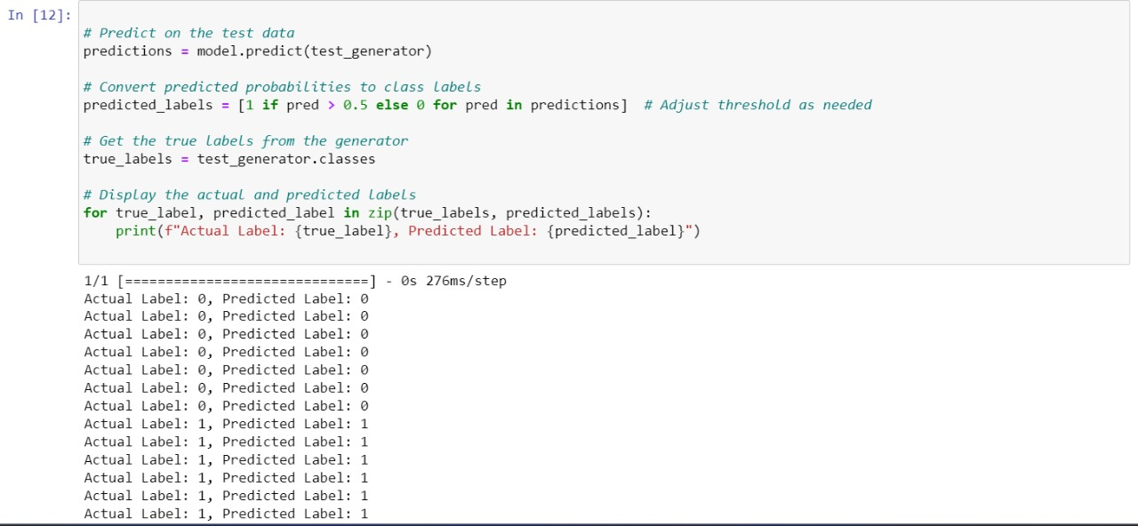

### Screenshot 4-

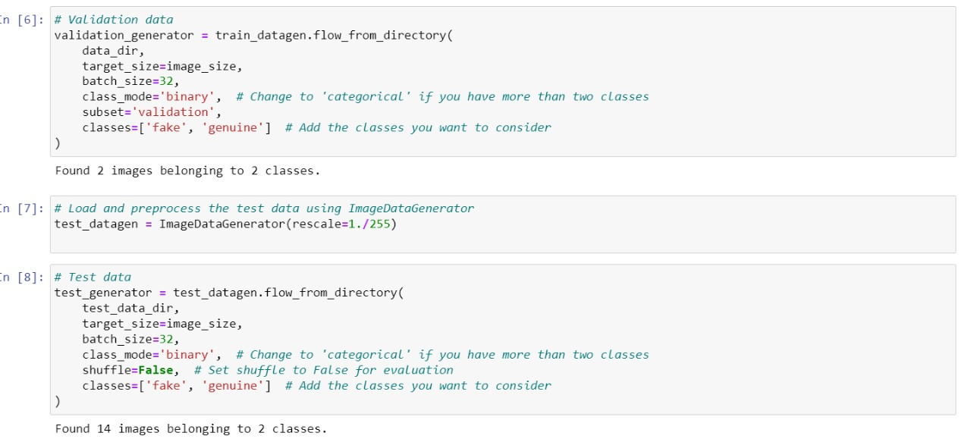

### 

**3.2 Implementation and Result**

The initiation of fake currency detection involves compiling a comprehensive dataset that includes images of authentic as well as forged currency notes. To ensure standardized inputs, the dataset undergoes preprocessing using an ImageDataGenerator, including resizing images and normalizing pixel values through the convolutional layer, dense layer and flattened layer.

In Convolutional layers

- The first Conv2D layer has 32 filters with a 3x3 kernel, using the ReLU activation function. The input shape is set to (128, 64, 3), indicating an image with dimensions 128x64 pixels and 3 colour channels.

- MaxPooling2D layer with a pool size of (2, 2) follows to downsample the spatial dimensions.

- The second Conv2D layer has 64 filters with a 3x1 kernel and uses the ReLU activation function. Another MaxPooling2D layer follows.

- The third Conv2D layer has 128 filters with a 3x3 kernel, again using the ReLU activation function, followed by another MaxPooling2D layer.

Then the flattened layer is used to flatten the output from the convolutional layers into a 1D array, preparing it for the fully connected (dense) layers.

After that, the final Dense layer has 1 unit with a sigmoid activation function, which is typical for binary classification problems. It outputs a probability indicating the likelihood of the input belonging to the positive class. This CNN comprises three convolutional layers, each followed by max-pooling layers, facilitating hierarchical feature extraction. Dense layers are subsequently employed for effective feature processing and binary classification, with the model compiled using the Adam optimizer and binary cross-entropy loss. The training phase involves the use of data generators, specifically configured through flow_from_directory. This ensures efficient processing of batches during model training, enhancing both speed and resource utilization. The model is evaluated on a separate validation set, and its accuracy is measured using the evaluate method, providing insights into its performance on unseen data. Post-training, predictions are generated on the test set, and a crucial step involves the conversion of predicted probabilities to binary class labels. The chosen threshold, commonly set at 0.5, determines the classification of each sample. This matrix is further visualized using seaborn for enhanced interpretability. The analysis extends to a classification report, providing precision, recall, and F1-score metrics, offering a nuanced understanding of the model's effectiveness in distinguishing between genuine and fake currency notes. This documentation serves not only to ensure clarity but also facilitates reproducibility. Features are extracted using the Conv2d, and MaxPooling2d layers of the CNN model from the currency note's images, these features include depth, spatial dimension etc. CNN is used as the machine learning model for fake currency detection and trained the selected model on the dataset, using the relevant features as input and Accuracy matrix for the final output. There are 30 images in our dataset and the dataset consists of two folders test and train, each test and train folder consist of two subfolders fake and genuine and each of the subfolder contains 7,8 images respectively. The output of the classifier will be above 50% for genuine banknotes and below 50% for fake banknotes. The proposed system produces approximately 85% accuracy so far. This is because of the small data size. The summary encapsulates key findings, including model accuracy, and addresses challenges encountered during the project. It serves as a roadmap for future work, suggesting potential improvements or avenues for exploration, thereby concluding a comprehensive and systematic approach to fake currency detection.

**Fig.6: confusion matrix**

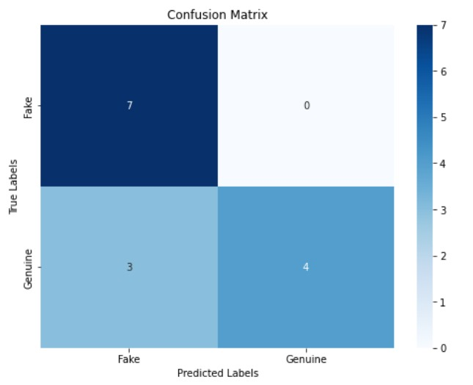

**Fig. 6. and represents the Confusion matrix and the accuracy table is presented to showcase class-wise detections.**

**Table1: accuracy table**

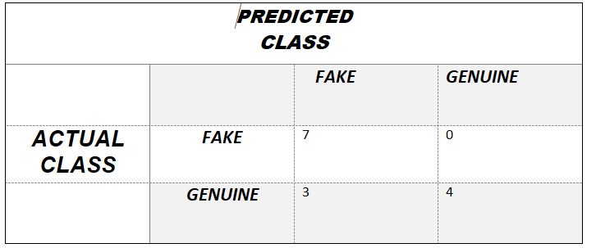

**Test Accuracy**

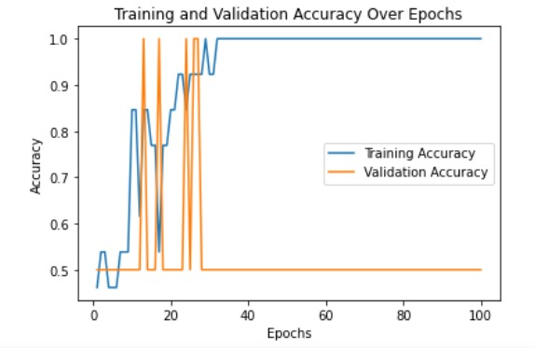

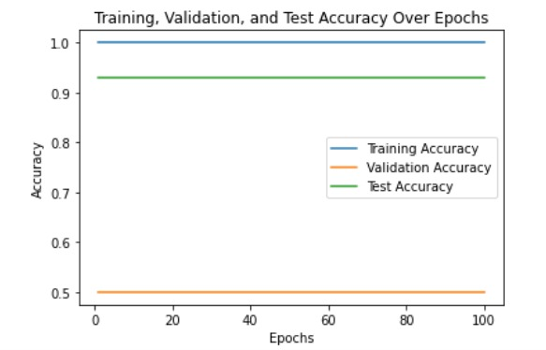

* 1. **ADVANTAGES AND DISADVANTAGES OF THE SYSTEM**

#### ADVANTAGES:

**Increased Accuracy:** ML & AI systems can achieve a high level of accuracy in counterfeit currency detection. They can identify subtle patterns and features that may be difficult for human inspectors to spot.

**Efficiency**: ML & AI systems can process a large number of currency notes quickly and consistently, making them ideal for high-throughput environments like banks, ATMs, and cash-handling businesses.

**Reduced Human Error:** Human inspectors may make mistakes or be influenced by factors such as fatigue or distractions. ML & AI systems, once properly trained, maintain their accuracy and consistency.

**Cost-Efficiency:** Over time, ML & AI systems can be more cost-effective than hiring and training human inspectors. They reduce labour costs and can operate 24/7 without rest.

**Quick Response:** ML & AI systems can detect counterfeit currency in real-time, leading to immediate alerts and actions, which is crucial in preventing the further circulation of fake notes.

**Adaptability:** Machine learning models can adapt to new counterfeit techniques. When provided with updated training data, they can learn to detect new variations of counterfeit currency.

#### DISADVANTAGES:

**Cost of Implementation:** Setting up an ML & AI system for fake currency detection can be expensive, involving the cost of hardware, software, data collection, and model development.

**Initial Data Collection:** Gathering a diverse and comprehensive dataset of genuine and counterfeit currency notes can be a time-consuming and costly process.

**Model Development Complexity:** Developing an effective ML & AI model for counterfeit currency detection requires expertise in machine learning and data science, which may not be readily available in all organizations.

**Model Training Time:** Training machine learning models, especially deep learning models, can be computationally intensive and time-consuming.

**Maintenance and Updates:** ML & AI models require regular maintenance and updates to remain effective, as counterfeiters may adapt their methods over time.

**False Positives and Negatives:** ML & AI models may produce false positives (genuine notes classified as counterfeit) and false negatives (counterfeit notes classified as genuine) under certain conditions, which can be a challenge to reduce.

**CONCLUSION AND FUTURE SCOPE**

In this paper, we have proposed a technique for detecting Indian counterfeit notes. Identifying counterfeit currency is a need of an hour. Also, it has been a challenge for researchers to contribute to society by identifying and detecting counterfeit currencies with the best possible solutions. The proposed approach follows an image processing technique followed by the machine learning technique. With the use of CNN-based approaches, the identification of counterfeit notes is easier and more accurate. However, there is a need for accurate testing in a variety of currency situations for a complete verification of the proposed approach, which shall be the immediate future work. Furthermore, there is a scope to detect counterfeiting of all kinds of country-specific banknotes. Also, the use of Deep Learning techniques with large amounts of training data may be applied for better predictions.

**BIBLIOGRAPHY**

Websites we used for our research

* www.geeksforgeeks.org
* www.javatpoint.com
* www.towardsdatascience.com